Task 2: User Management and Access Control

Objective: Set up user accounts and configure secure access controls for the new developers.

Scenario:

Two new developers, Sarah and Mike, require system access.
Each developer needs an isolated working directory to maintain security and confidentiality.
Security policies must ensure proper password management and access restrictions.

Requirements:

- Create user accounts for Sarah and Mike with secure passwords
- Set up dedicated directories:
Sarah: /home/Sarah/workspace
Mike: /home/mike/workspace
- Ensure only the respective users can access their directories using appropriate permissions.
- Implement a password policy to enforce expiration and complexity (e.g., passwords expire every 30 days).

- Create user accounts for Sarah and Mike with secure passwords

Example Output

> whoami
root
> id sarah
id: ‘sarah’: no such user
> id mike
id: ‘mike’: no such user
> sudo useradd -m sarah
> sudo passwd sarah
New password:
BAD PASSWORD: The password is shorter than 8 characters
Retype new password:
passwd: password updated successfully
> sudo useradd -m mike
> sudo passwd mike
New password:
BAD PASSWORD: The password is shorter than 8 characters
Retype new password:
passwd: password updated successfully
> id sarag
id: ‘sarag’: no such user
> id sarah
uid=1004(sarah) gid=1006(sarah) groups=1006(sarah)
> id mike
uid=1005(mike) gid=1007(mike) groups=1007(mike)

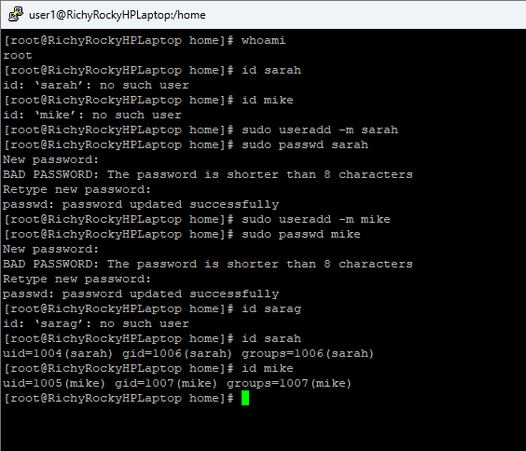
User sarah has been added
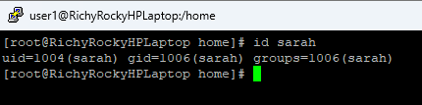

Sarah home directory /home/sarah
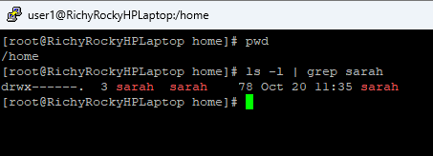

User mike has been added
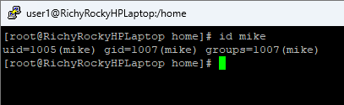

Mike home directory - /home/mike
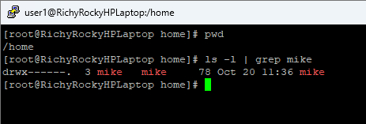

- Set up dedicated directories:
Sarah: /home/Sarah/workspace
Mike: /home/mike/workspace

Sarah dedicated directory - /home/sarah/workspace
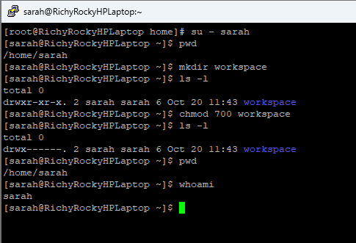

Mike dedicated directory - /home/mike/workspace
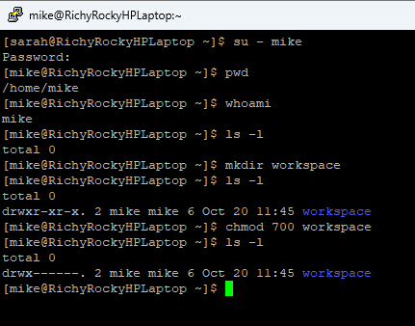

- Ensure only the respective users can access their directories using appropriate permissions.

Sarah trying to access Mike’s directory and getting **permission denied**
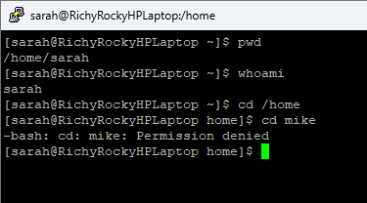

Mike trying to access Sarah’s directory and getting **permission denied**
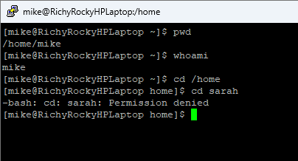

- Implement a password policy to enforce expiration and complexity (e.g., passwords expire every 30 days)

Password policy for Sarah account

Existing Password policy for Sarah
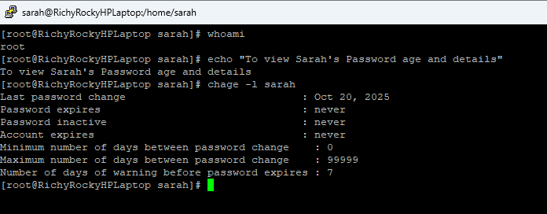

After changing the password policy (expiration) for Sarah
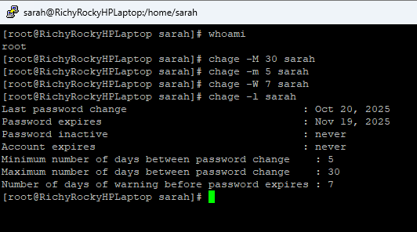

Password policy for Mike account

Existing Password policy for Mike
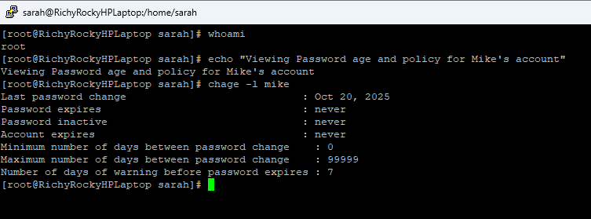

After changing the password policy (expiration) for Mike account
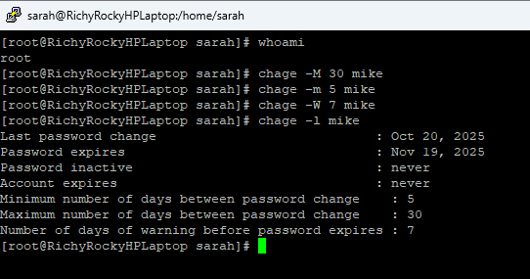

Password Complexity

/etc/pam.d/system-auth
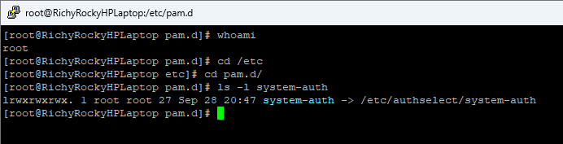

Default password complexity

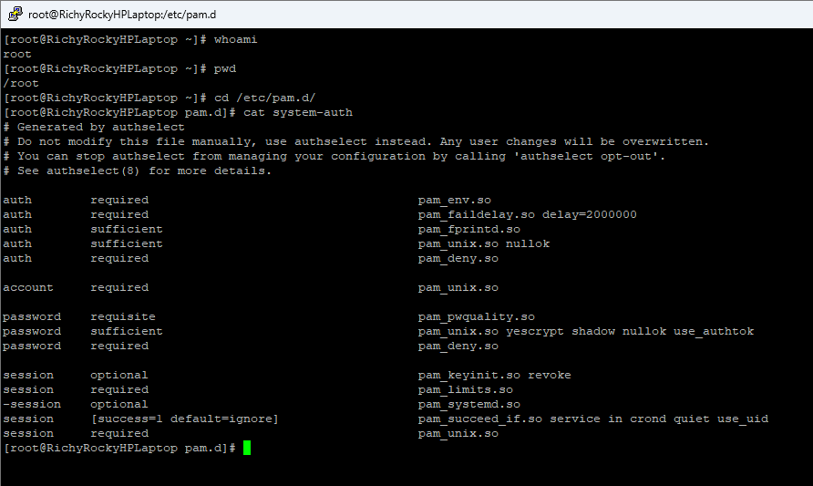

To enforce password quality rules –
Add the below parameters in /etc/pam.d/system-auth file
```
password requisite pam_pwquality.so retry=3 minlen=12 maxrepeat=3 ucredit=-1 lcredit=-1 dcredit=-1 ocredit=-1 difok=4 reject_username enforce_for_root
```
vi /etc/pam.d/system-auth
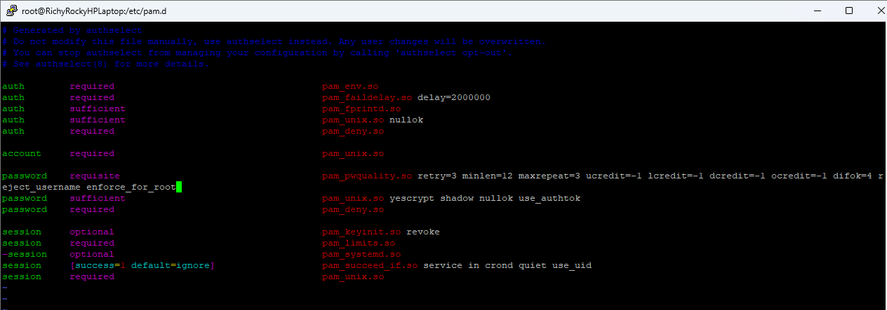

After adding the above parameters for Password Complexity
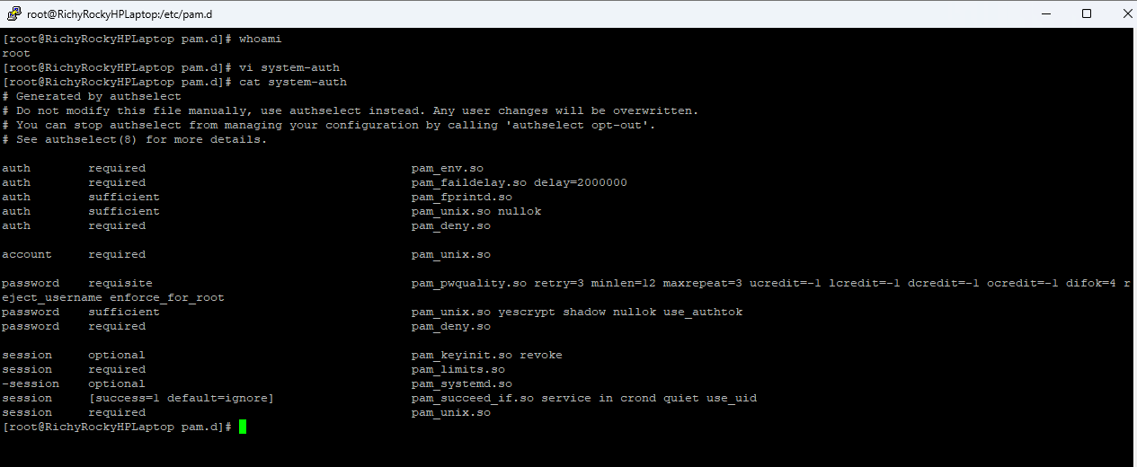

<<<End of the task>>>

